

Blackboard, Inc. Analysis, Part 2: Financial Performance
Published by Jim Farmer August 27th, 2008 in Higher Education and Tools, Toys, and Technology (Oh my!).
Tags: Blackboard Inc., edunomics.

Investors should be pleased with Blackboard’s stock prices. The stock prices consistently outperform the NASDAQ Composite Index. [1]
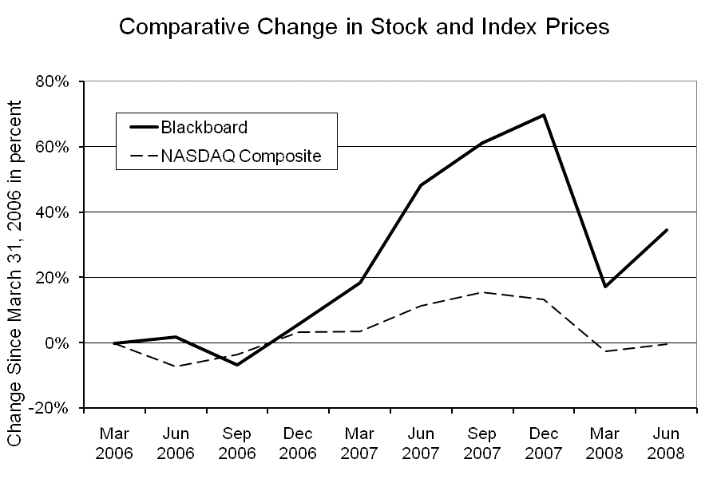
Financial analysts continue to rate the stock as outperforming the market with buy and strong buy recommendations. Each quarter Blackboard CEO Mike Chasen, CFO Mike Beach and Senior Vice President Mike Stanton brief analysts winning appreciative comments. They also make presentations at conferences of financial analysts with similar responses.

For the first time since the acquisition of WebCT in January 2006, during the August 6, 2008 Earnings Conference Call analyst Amy Junker of Robert Baird asked about open source. She asked: “Michael Chasen, I was hoping you spend a minute to talk about the announcement that you made with the plan to develop the Sakai Integration, what exactly do you hope to achieve with that announcement and can you talk a little bit on the timing?” [3] Chasen responded:
Sure at the Blackboard World, we talked about how in the future of our product and this is an issue we are actually working closely with a couple of universities on, that our learning system will be able to load other course management system courses through our interface. One of the issues they were having is a lot of campuses have standardized on the Blackboard system and we are the standard product for almost the entire campus, but there maybe an individual teacher or a very small department that is using either a home-grown system or maybe an open-source solution and then why really should the students or faculty members have to go to a separate url or a separate log-in to be able to access those courses.
So recognizing that Blackboard is that campus industry standard we have actually gone ahead and opened up our course management APIs to allow for home-grown systems or home-developed systems or other third-party systems to be served if you will and load through our interfaces so that you can log in once and access all of their courses whether they are Sakai courses as you mentioned or other open source or home-grown solutions all from the Blackboard Interface and I think this will help improve teaching and learning on the campus because you are able to aggregate all of your courses in one area.
A similar question was asked during Blackboard’s briefing at the CanAccord Adams Conference August 12th. [4] Chasen identified Sakai as the primary of two open source competitors.

Blackboard Strategy
Blackboard has a three-part strategy for financial success.
- Continue to add features so Blackboard can compete when Request for Proposals are issued or other formal or informal feature comparisons are made during procurements.
- Expand the product line so Blackboard can “cross-sell” these products to current clients.
- Broaden the market to include K-12, corporate, government and international clients.
Blackboard has expanded the product line by acquiring products and companies. Blackboard was able to dominate the market by acquiring WebCT—its largest higher education competitor. This was possible because the U.S. Department of Justice considered the larger market in the U.S. including training as well as learning systems. Other firms, such as SumTotal Systems, then have significant market share. Blackboard was then not considered dominate and the U.S. Department of Justice declined to initiate antitrust action.
Blackboard has been able to integrate these products and companies without any significant cost consequences, hence maintaining profitability. The gross margin—revenue minus cost of goods sold—has been steady between 73% and 79% [5] The gross margin for professional services has varied, likely because sometimes professional services revenues are included in product sales (e.g. implementation) with the costs of professional services remaining constant. Professional services is a small part of Blackboard revenue.
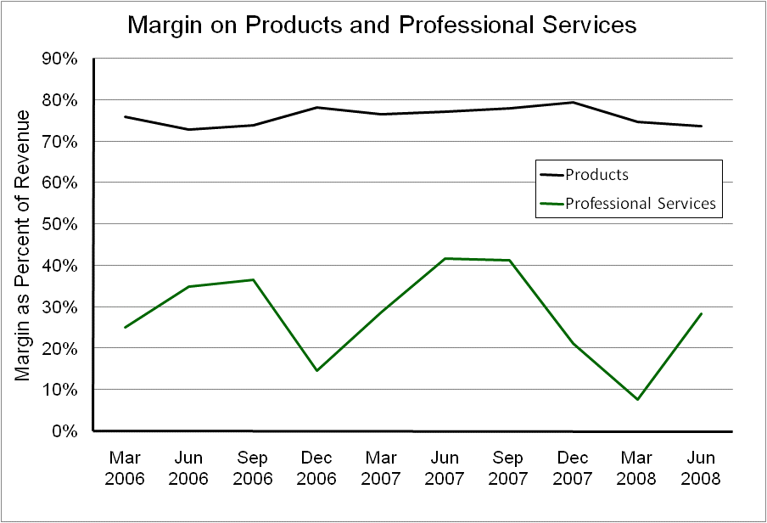
With very steady growth product revenue has almost doubled since WebCT was acquired in January 2006.
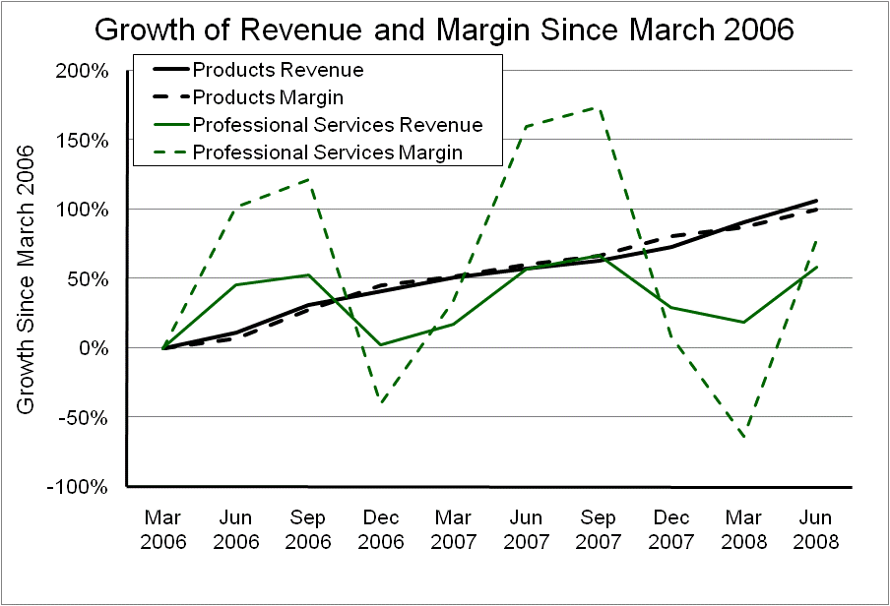
Blackboard uses subscription pricing. That is, each year there is a charge for using the software for the coming year. Earlier software was priced with a single license fee and then a fee each year for upgrades and technical support. This fee began in the 1960s at 10% and has increased now as hjgh as 26% of either the original or the current license fee. [6] Blackboard has always used subscription pricing and frequently explains the advantages during presentations to financial analysts.
Blackboard has been able to merge companies and products without changing the basic financial model. There has been a general trend to reduce the cost of products and sales and marketing and research and development and general administration as a combination of financial management and economies of scale. The increased cost—predicted by CFO Mike Beach— in recent quarters comes from the acquisition of NTI which is being more widely marketed, especially to government to enhance security.
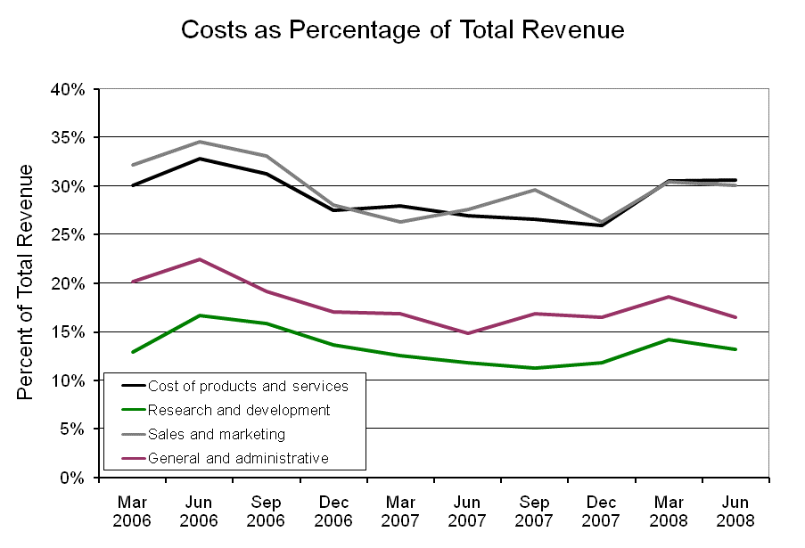
Even though revenue and expenses have increased steadily, small changes can cause significant changes in profit. Revenue and computed profit and the increasing profit trend are shown in the chart “Quarterly Revenue and Net Income.”
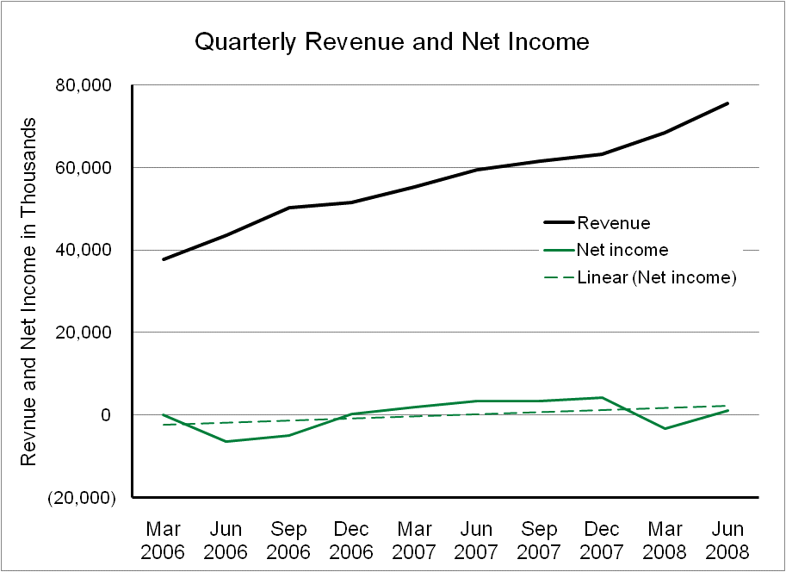

Average Revenue per Client
The success of the “cross selling” strategy can be seen from data given recently by Blackboard. In the seven years from founding to the merger with WebCT, Blackboard’s revenue per client increased 600%. In the period from November 2005 to March 2008 the increase has been 57%. [7]
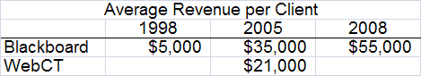

Retention of Clients
Because of the response of the higher education community to the Blackboard patent litigation with Desire2Learn Inc. and the emergence of open source course management systems, some predicted Blackboard’s client retention rate would decrease. It continues to increase. [8]
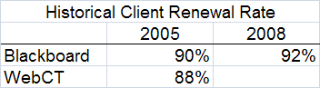
Blackboard cites its “suite” of applications and implicit integration as an incentive to retain the software. And it likely is.
Data from the United Kingdom shows some of the trends which may apply to the growing European market as well. These continuing trends: (1) The number of universities and colleges without a learning system decreased an additional 3.8%, (2) The number of “in house” systems that are no longer the principal system decreased an additional 19.9%–a total of 23.7%. 15.4% of this decrease became additional installation of Blackboard Inc. systems, one Desire2Learn installation, and a 7.2% increase in Moodle installations. (3) Open source Moodle continued to be the fastest growing system, likely because its use by Further Education colleges. Systems that did not emerge as principal systems between surveys include: Bodington, Colloquia, FD Learning, Firstclass, Granada Learnwise, Lotus, Merlin, and Top Class. In addition Microsoft Sharepoint was listed as a learning system only in 2005. [9]
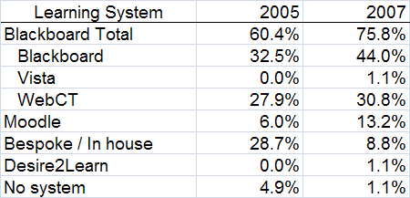
The 2007 survey asked for a single principal virtual learning environment (VLE) or learning system; the 2005 survey asked for all installed VLEs. This chart shows 2005 market share for 2005 only for those learning systems (VLE) that were reported in the 2007 survey and the market share recomputed. [9]
Similarly in the U.S. higher education the Blackboard product has a 40% market share and the former WebCT product has a 33% market share. This is down 3% from Fiscal Year 2004. No other product has more than 5% of the market. In various market segments open source, Jenzabar, Desire2Learn and Angel exceed 5%, but are less than 6%. Open source has an 18.2% market share in BA institutions, but not DR or AA. “Course management systems are nearly universally in use at all types of institutions, with more than 98% [up from 96% in Fiscal Year 2004] of DR, MA, and BA institutions reporting having these systems.” 18.2% plan on changing systems within the next three years, up from 13% in Fiscal Year 2004.[10, 11]
The change of learning systems requires faculty retraining—users who have limited time and interest for the task. For this reason fewer colleges and universities appear to be changing than had said they would change. Sun Microsystem’s Scott McNealy, writes: “In business, that’s called a barrier to exit. [Software] companies that create barriers to exit figure we won’t notice until it’s too late when the cost of switching is too high.” [12] Because of the complex nature of college and university instruction and learning, and very limited resources, the “barrier to exit” is high for any higher education learning system.

The Future
The data suggests Blackboard will continue to dominate learning systems in U.S. higher education and have major market share in other countries. With careful cost control, the Blackboard financial team will be able to continue to increase revenue and profitability. And the stock prices should continue to outperform the market average.
Unless there is a major disruption in the market.
There are two possibilities. As analysts asked at the August 6th Earnings Conference Call and the subsequent August 12th presentation at the Canaccord Adams Conference, open source is gaining market share and could become a competitor. At this time one open source system is showing sustainability in the sense of being free of institutional subsidies as contrasted to institutional memberships, payments for services, and external capital infusions. Blackboard did not identify this potential competitor, or provide any data about its performance in the market. [13]
There is a more significant uncertainty. The recent Higher Education Opportunity Act (House Resolution 4137, 110th Congress at the Second Session, July 30, 2008) begins to indirectly regulate faculty choices and use of publisher and open education resources, institutional practices providing learning resources and information about learning resources, and publisher pricing and information practices. Proposed rule-making begins in October and the rules become effective July 2010.
“This fall more than 17 million students will be using publisher-provided online services.” [14] Most of these services are paid for through the purchase of new (not used or rented) textbooks. If universities and colleges decline to pay for these online services, then students will need to subscribe directly with publishers for these learning materials. If so, this bypasses the institutional learning system. With publisher cooperation it may be possible to create a learning management system where “management” then would apply to publisher-provided online learning services. This could obsolete current course management systems and force conversions.[15] Based on past practices, institutions are likely to ask students to pay—especially since that is what the student lobbyists asked for. And faculty will have some difficult decisions.

End Notes
[1] Closing stock price at the end of each quarter. Data from Yahoo Finance, 18 August 2008.
[2] From Yahoo Finance, 18 August 2008.
[3] From “Blackboard Inc. Q2 2008 Earnings Call Transcript” by SeekingAlpha posted 6 August 2008 pages 11-12.
[4] Jim Farmer, instructional media + magic, inc., “Notes from the Blackboard Inc. Presentation at the Canaccord Adams Annual Global Growth Conference 12-14 August 2008, Boston, Massachusetts USA,” page 1, 00:19:02.
[5] These computations are based on data from the Non-GAAP financial statements provided as press releases at the same time the SEC Forms 10-K and 10-Q are filed.
[6] Software licensing may have began in Los Angeles in 1964 based upon the recommendation of Haskins & Sells. They recommended the 10% annual rate though sometimes competition created a rate as low as 8%. National data for that period is not available. This is based on data from Systems Research Inc. The subsequent rates are based on those revealed during discovery in Oracle Corporation’s litigation with PeopleSoft and other firms and publically available as court documents.
[7] The 1998 and 2006 values were given by Michael Chasen in response to a question at the Canaccord Adams Conference; see the notes page 3 00:23:02 The 2005 values were taken from “WebCT, Inc. Transaction Briefing,” Blackboard Inc., 12 October 2005, slide 7.
[8] The 2005 values were taken from “WebCT, Inc. Transaction Briefing.” Blackboard Inc., 12 October 2005, slide 7. The 2008 value was taken from “Blackboard Inc. Q2 2008 Earnings Call Transcript” by SeekingAlpha posted 6 August 2008 page 4.
[9] See James Farmer, “The Use of Virtual Learning Environment Software in UK Universities 2001-2005, 16 June 2006, Appendix A, page 9. Public data for the UCISA (Universities and Colleges Information Systems Association) 2007 survey was taken from their website www.ucisa.ac.uk/members/surveys/cis_2007.aspx on 18 August 2008.
[10] Brian L. Hawkins and Julia A. Rudy, EDUCAUSE Core Data Service, Fiscal Year 2006 Summary Report, September 2007, page 52-58.
[11] James Farmer, “Software Trends in Higher Education: 2002-2004,” instructional media + magic, inc., 27 November 2006, page 3.
[12] Scott McNealy, “Software Hardball,” Dow Jones Reprints, March 3, 2006.
[13] This may be done in another part of this series.
[14] James Farmer, “Distributed Learning is Here: Just Ask Any College Student,” e-Literate, July 20, 2008 (mfeldstein.com/distribute-learning-is-here-ask-any-college-student).
[15] This technology is currently available in systems used for government and corporate training.

